***PROJECT REPORT***

***TOPIC : FINANCIAL ANALYSIS OF BANKS IN TABLEAU***

***TEAM MEMBERS***

***VADAREVU SAI SAMPRREET KHUSHAL (20BCE2537)***

***PRATIK PAVAN MEDHANE (20BCE10312)***

***SUBRAMANYA ABHIRAM CHALLA (20BCE2533)***

***PRABHATH CHODAVARAPU (20BCE2740)***

**PROJECT FLOW**

The Project is successfully completed in the sequence given below:

* **Introduction**
* **Problem Statement**
* **Data Set Description**
* **Data Representation and Use**
* **Visualization Created**
* **Dashboard**
* **Story**
* **Web Integration**
* **Project Demonstration and Documentation**
* **Findings**
* **Result**
* **Application**
* **Conclusion**
* **Future scope**

**INTRODUCTION**

WHAT IS FINANCIAL ANALYSIS?

Financial analysis is the process of evaluating and interpreting financial data to assess the performance, stability, and viability of an entity, such as a company or investment. It involves analysing financial statements, ratios, and other indicators to gain insights into profitability, liquidity, solvency, and growth potential. Financial analysis is essential for decision-making, risk assessment, and understanding the financial health of an entity.

WHY DO WE NEED FINANCIAL ANALYSIS?

Financial analysis is crucial for decision-making, performance evaluation, risk assessment, investment decisions, financial planning, compliance, and stakeholder communication. It provides valuable insights into the financial health and performance of businesses and investments, enabling informed choices, identifying areas for improvement, evaluating risks, guiding investment strategies, facilitating effective planning, meeting reporting obligations, and fostering transparency and accountability among stakeholders.

WHY IS FINANCIAL ANALYSIS OF BANKS NECESSARY?

Financial analysis of banks is necessary for several reasons. It helps assess the stability, solvency, and risk exposure of banks, ensuring their ability to meet obligations. It ensures regulatory compliance and provides accurate information for reporting. Financial analysis evaluates a bank's financial performance, profitability, and efficiency, instilling investor confidence. Additionally, it supports decision-making in mergers and acquisitions by assessing target banks' financial position. Overall, financial analysis of banks enables effective risk management, regulatory compliance, informed decision-making, and investor trust in the banking industry.

**PROBLEM STATEMENT**

*TO ANALYZE AND DERIVE MEANINGFUL INFORMATION ABOUT THE FINANCIAL STATUS OF THE TOP BANKS ACROSS THE WORLD.*

*TO DEMONSTRATE THE DERIVED INFORMATION PUBLICLY USING WEB INTEGRATED SOLUTIONS.*

**DATASET DESCRIPTION**

The dataset "top100banks2017-12-31.csv" contains information about the top 120 banks as of December 31, 2017. The Dataset Provides to following Information:

* *Rank*: This column represents the ranking of each bank based on its total assets. The banks are listed from 1 to 120, with 1 being the bank with the highest total assets.
* *Bank*: This column provides the names of the banks included in the dataset. It identifies the specific financial institutions being analysed.
* *Country*: This column indicates the country in which each bank is headquartered. It highlights the global distribution of the top banks and provides insights into the dominance of certain countries in the banking sector.
* *Total_assets_us_b*: This column represents the total assets of each bank in billions of US dollars. Total assets are a crucial measure of a bank's financial strength and size. It includes various components such as cash, loans, investments, and other assets held by the bank.
* *Balance_sheet*: This column specifies the date of the balance sheet for which the total assets are reported. It helps to understand the time frame of the financial information and allows for comparisons between different periods.

By examining this dataset, you can analyse and compare the size and financial standing of the top banks worldwide. It provides valuable insights into the global banking industry, the dominance of specific countries or regions, and the relative strength of individual banks based on their total assets.

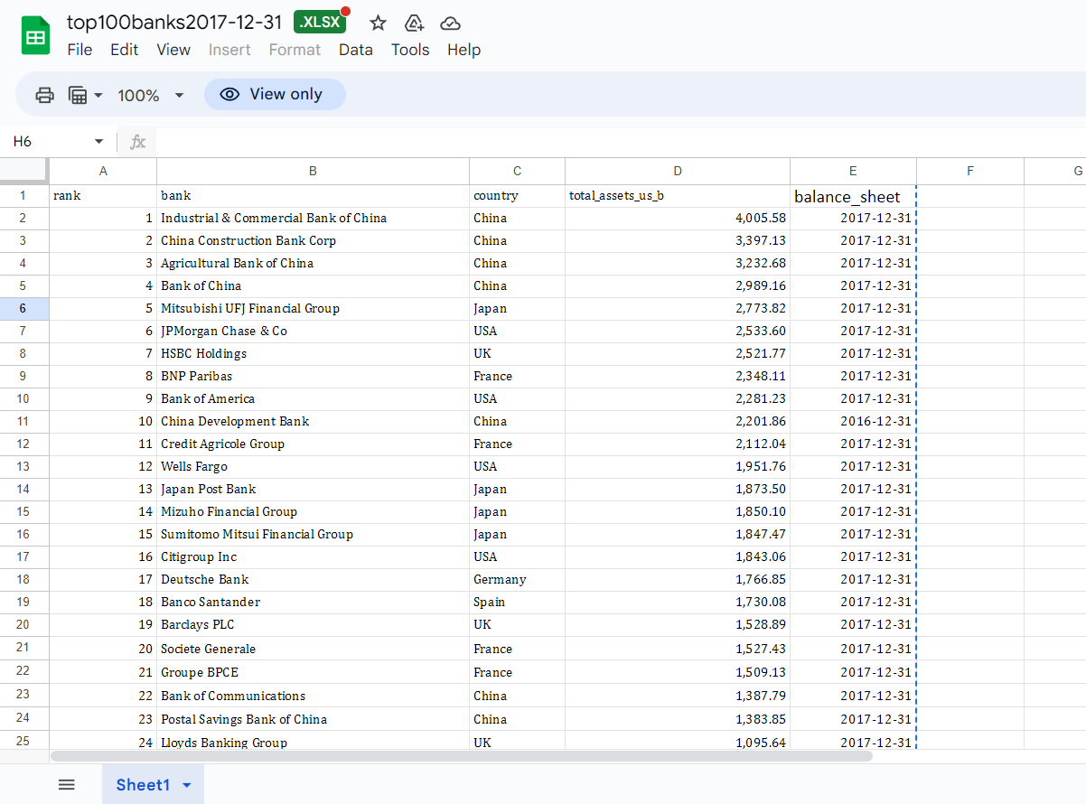

**DATA REPRESENTATION AND USE**

The above data extracted from the dataset can be used to create meaningful visualizations which can help paint a better picture about the financial status of the top 100 banks. Dashboards and Stories will be used to display our findings.

The visualizations for the project will be completed in Tableau.

The data extracted from the dataset as well as the type of data and how it can be used in visualizations as follows:

* Rank – Linear Charts (Line Chart / Bar Graph) - Measure
* Bank – Pie and Linear Charts and Maps – Dimension
* Country – Maps – Dimension
* Total_assets_us_b – Linear Charts – Measure
* Balance_sheet – Gantt Charts and Linear Charts – Date

To leverage the capabilities of Tableau to create insightful and interactive visualization that effectively communicate and financial performance of the banks. We have integrated the financial data into Tableau by connecting to data sources or importing the data directly. Ensuring that the data is properly structured and linked for accurate analysis. Designed and developed interactive dashboards in Tableau to display key financial metrics and ratios. The dashboard can include various visualization such as line charts, bar charts and tables to showcase trends, comparisons and insights.

**VISUALIZATIONS CREATED**

The visualizations created for the project are as follows:

*Bar Chart - Bank vs Total Assets vs Country*

*Map - Bank vs Country vs Total Assets*

*Symbol Map - Bank vs Country vs Total Assets*

*Tree Map - Bank vs Total Assets vs Rank*

*Line Chart - Bank vs Total Assets*

*Area Chart - Bank vs Total Assets vs Rank*

*Pie Chart - Country vs Total Assets*

*Pie Chart - Country vs Total Assets (With Parameters)*

*Bar Chart - Country vs Rank vs Total Assets*

*Bar Chart - Country vs Rank vs Total Assets (with Parameter)*

*Heat Map - Balance Sheet vs Bank vs Total Assets*

*Highlight Table - Top 20 banks by rank vs Total Assets*

**DASHBOARD**

Dashboards in Tableau are visual representations of data that provide an interactive and consolidated view of key metrics, trends, and insights. They allow users to analyse and explore data from multiple sources through interactive charts, graphs, maps, and other visual elements.

Dashboards enable users to monitor key performance indicators, identify patterns, and make data-driven decisions in real time.

With intuitive drag-and-drop functionality, filters, and drill-down capabilities, Tableau dashboards empower users to gain a comprehensive understanding of their data, spot trends, and uncover actionable insights. They facilitate effective data communication and storytelling by presenting complex information in a visually appealing and easily digestible format, enhancing data-driven decision-making across organizations.

The Dashboard that was developed and deployed by us:

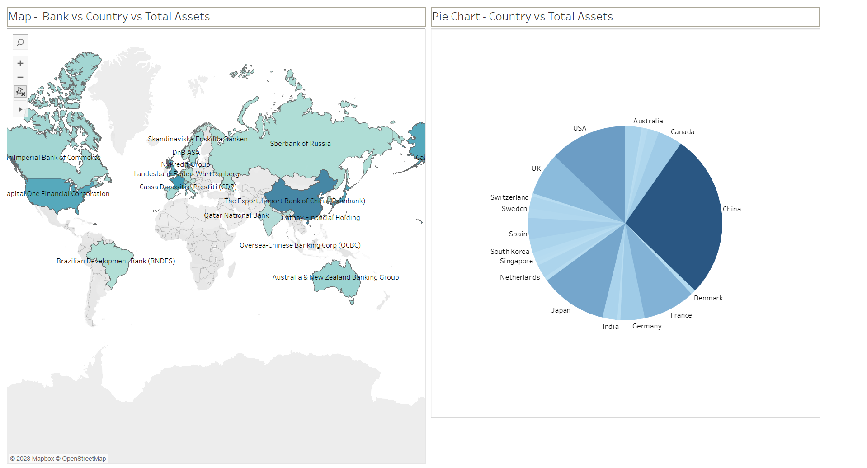

**STORY**

Stories in Tableau are a powerful feature that allow users to present a sequence of visualizations, dashboards, and interactive content in a narrative format.

Stories enable the effective communication of insights and trends by guiding viewers through a data-driven story arc. They provide context, highlight key findings, and allow for a cohesive storytelling experience. With stories in Tableau, users can combine various visualizations, annotations, and text to create a compelling and interactive narrative that engages the audience and helps them understand the data and its implications more effectively.

The Story which was developed and deployed by us:

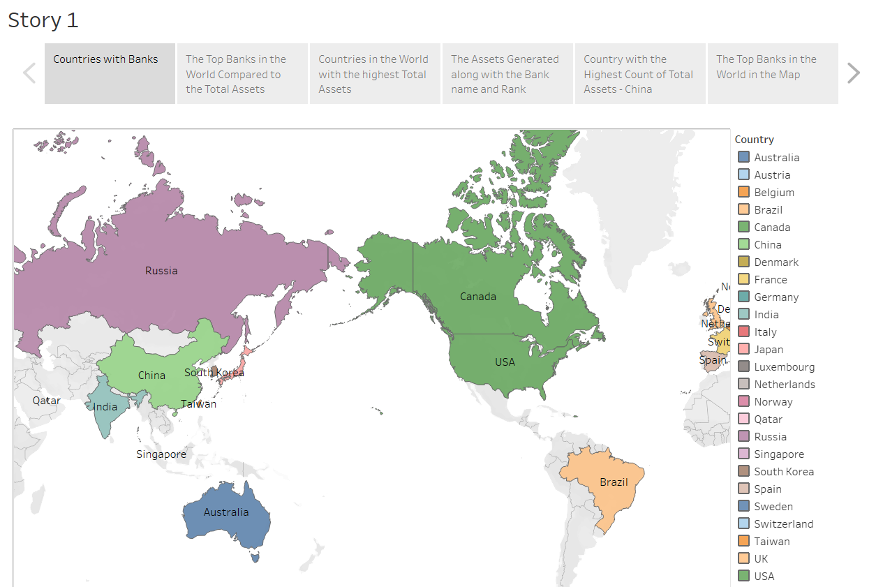

**WEB INTEGRATION**

The web Integration process was done using a bootstrap template – “Selecao” and was host on a private IP address using flask.

The code for flask is given below:

from flask import Flask, redirect, url_for,render_template

app = Flask(__name__)

@app.route("/")

def home():

    return render_template("index.html")

if __name__ == "__main__":

    app.run(debug=False,port=8000)

The snippets of the result of the following website is as follows:

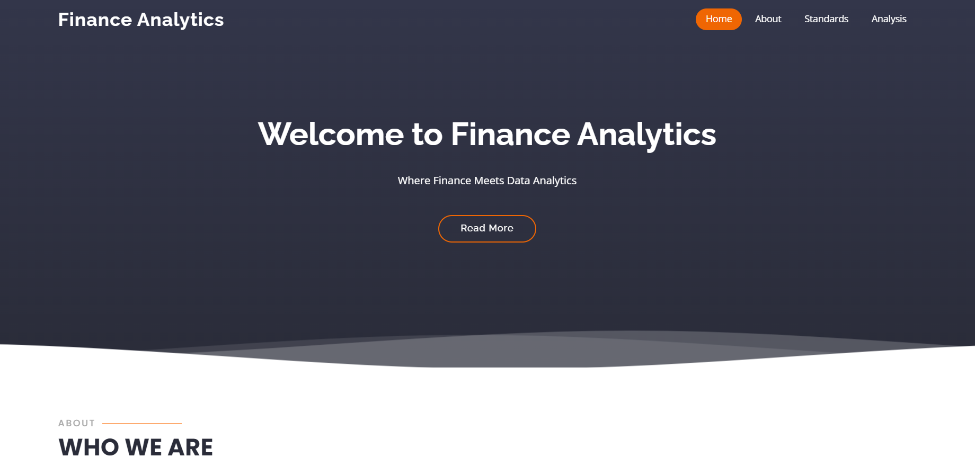

**FINDINGS**

The overall findings and discoveries about new information from the visualizations are as follows:

* The country with the highest Bank to Total Assets Ration is China.
* Industrial & Commercial Bank of China has the lowest rank and the highest Total Assets of all the Banks in the Data Set.
* Most of the Banks in the Data Set are located in Europe.
* China, USA and Japan are the top 3 countries with the highest Total Assets.
* The Average Total Assets of all Banks in the Data Set is 832.
* The Average Rank of all Banks by country in the Data Set is 290.4.
* The country with the lowest Total Assets is Qatar at 221.
* The Top 3 Banks in the Dataset are located in China.
* The bank with the least rank is Belfius at 120 with Total Assets of 201.

**RESULT**

The Financial analysis of banks helped us understand which provinces had more banks stood a better chance in the market. It was also useful to know the countries in which the most number of top banks were located in as these places would be the hub for the finance oriented industries. It also helps us understand which countries promote financial institutions more than the other countries. Helps us understand which countries will make it easier to acquire assets compared to the other countries.

From the above information we can also found that China , USA and Japan are the best countries to start a bank compared to other countries due to the high number of successful banks in these countries. This shows that the laws in these countries smoothen the path for business in the banking sector.

**APPLICATIONS**

By knowing the countries with the highest number of top ranking banks as well as the assets generated by the banks in such countries, future banking investors can take a well calculated decision to invest in banks which are located in countries or areas favourable for the banking sector to flourish. As we have determined in the result section that China , USA and Japan are the best countries for banks to thrive in, investors can use the information uncovered from our project to invest in banks wisely to facilitate favourable results.

**PROJECT DEMONSTRATION AND DOCUMENTATION**

The Link for the Recording is given below:

The Link for the GitHub repository is given below:

**CONCLUSION**

In Conclusion, The Financial analysis of banks is a very important procedure to understand the growth and shrinking of banks and their assets linked to particular countries, location or time factors. Such information cannot be discovered by just witnessing the raw data from the dataset as this data is indirect. Discovering this indirect data allows us to better understand and improve the chances of financial institutions survival. Hence the financial analysis of banks can conclude that some places are more favourable to open banks at a particular time as comparted to other places.

**FUTURE SCOPE**

The project can be broadened to include the financial analysis of the least performing banks and as to why that is the case. We also aim to figure out which countries are least suitable for a successful financial and commercial business in the banking sector and the reasons which produce such outcome.